大数据技术Hadoop之MapReduce
讲师：刘峰吉

一、WordCount案例

1、WordCount 案列简单分析
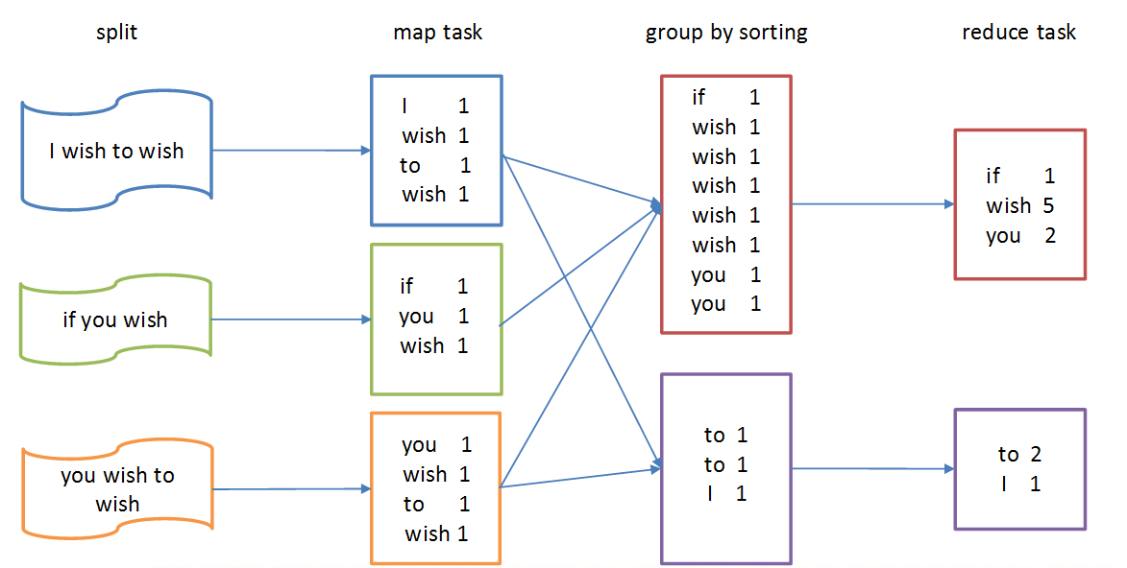

2、创建java项目
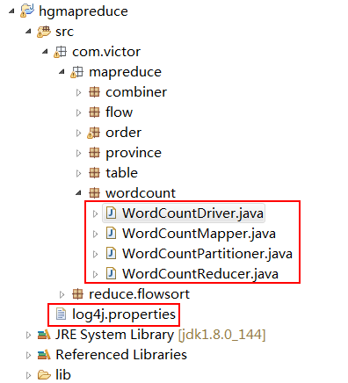

3、程序源代码

1）定义一个Mapper类
import java.io.IOException;

import org.apache.hadoop.io.IntWritable;
import org.apache.hadoop.io.LongWritable;
import org.apache.hadoop.io.Text;
import org.apache.hadoop.mapreduce.Mapper;

public class WordCountMapper extends Mapper<LongWritable, Text, Text, IntWritable>{

@Override
protected void map(LongWritable key, Text value, Context context)
throws IOException, InterruptedException {

// 1 获取一行数据
String line = value.toString();

// 2 截取
String[] words = line.split(" ");

// 3 发出去
for (String word : words) {
context.write(new Text(word), new IntWritable(1));
}
}
}

2）定义一个Reducer类
import java.io.IOException;

import org.apache.hadoop.io.IntWritable;
import org.apache.hadoop.io.Text;
import org.apache.hadoop.mapreduce.Reducer;

public class WordCountReducer extends Reducer<Text, IntWritable, Text, IntWritable>{

@Override
protected void reduce(Text key, Iterable<IntWritable> values,
Context context) throws IOException, InterruptedException {

int count=0;

// 汇总
for (IntWritable value : values) {
count += value.get();
}

context.write(key, new IntWritable(count));
}
}

3）定义一个Partitioner类
import org.apache.hadoop.io.IntWritable;
import org.apache.hadoop.io.Text;
import org.apache.hadoop.mapreduce.Partitioner;

public class WordCountPartitioner extends Partitioner<Text, IntWritable>{

@Override
public int getPartition(Text key, IntWritable value, int numPartitions) {

int result = key.toString().charAt(0);

if (result % 2 == 0) {
return 0;
}else {
return 1;
}
}
}

4）定义一个WordcountCombiner类
import java.io.IOException;

import org.apache.hadoop.io.IntWritable;
import org.apache.hadoop.io.Text;
import org.apache.hadoop.mapreduce.Reducer;

public class WordcountCombiner extends Reducer<Text, IntWritable, Text, IntWritable>{

@Override
protected void reduce(Text key, Iterable<IntWritable> values,
Context context) throws IOException, InterruptedException {

int count=0;

// 汇总
for (IntWritable value : values) {
count += value.get();
}

context.write(key, new IntWritable(count));
}
}

5）定义一个Driver主类，用来描述job并提交job
import org.apache.hadoop.conf.Configuration;
import org.apache.hadoop.fs.Path;
import org.apache.hadoop.io.IntWritable;
import org.apache.hadoop.io.Text;
import org.apache.hadoop.mapreduce.Job;
import org.apache.hadoop.mapreduce.lib.input.CombineTextInputFormat;
import org.apache.hadoop.mapreduce.lib.input.FileInputFormat;
import org.apache.hadoop.mapreduce.lib.output.FileOutputFormat;

public class WordCountDriver {

public static void main(String[] args) throws Exception {

// 1 获取配置文件信息
Configuration configuration = new Configuration();
Job job = Job.getInstance(configuration);

// 2 加载驱动类
job.setJarByClass(WordCountDriver.class);

// 3 加载map、reducer的类
job.setMapperClass(WordCountMapper.class);
job.setReducerClass(WordCountReducer.class);

// 4 指定map输出数据类型
job.setMapOutputKeyClass(Text.class);
job.setMapOutputValueClass(IntWritable.class);

// 5 指定最终输出数据的kv类型
job.setOutputKeyClass(Text.class);
job.setOutputValueClass(IntWritable.class);

// 分区
job.setPartitionerClass(WordCountPartitioner.class);
job.setNumReduceTasks(2);

// CombineTextInputFormat 切片 ，减少maptask个数，针对小文件
job.setInputFormatClass(CombineTextInputFormat.class);
CombineTextInputFormat.setMaxInputSplitSize(job, 4194304);
CombineTextInputFormat.setMinInputSplitSize(job, 2097152);

// maptask阶段的合并,复用WordCountReducer 类
job.setCombinerClass(WordCountReducer.class);

// 6 指定job的输入输出原始文件所在目录
FileInputFormat.setInputPaths(job, new Path(args[0]));
FileOutputFormat.setOutputPath(job, new Path(args[1]));

// 7 提交
job.submit();
boolean result = job.waitForCompletion(true);
System.exit(result ? 0 : 1);
}
}

4、源代码解析，把单词按照ASCII码奇偶分区（Partitioner）

1）自定义分区
import org.apache.hadoop.io.IntWritable;
import org.apache.hadoop.io.Text;
import org.apache.hadoop.mapreduce.Partitioner;

public class WordCountPartitioner extends Partitioner<Text, IntWritable>{

@Override
public int getPartition(Text key, IntWritable value, int numPartitions) {

int result = key.toString().charAt(0);

if (result % 2 == 0) {
return 0;
}else {
return 1;
}
}
}

2）在驱动中配置加载分区，设置reducetask个数
job.setPartitionerClass(WordCountPartitioner.class);
job.setNumReduceTasks(2);

5、源代码解析，对每一个maptask的输出局部汇总（Combiner）
统计过程中对每一个maptask的输出进行局部汇总，以减小网络传输量即采用Combiner功能。

方案一
1）增加一个WordcountCombiner类继承Reducer
import java.io.IOException;

import org.apache.hadoop.io.IntWritable;
import org.apache.hadoop.io.Text;
import org.apache.hadoop.mapreduce.Reducer;

public class WordcountCombiner extends Reducer<Text, IntWritable, Text, IntWritable>{

@Override
protected void reduce(Text key, Iterable<IntWritable> values,
Context context) throws IOException, InterruptedException {

int count=0;

// 汇总
for (IntWritable value : values) {
count += value.get();
}

context.write(key, new IntWritable(count));
}
}

2）在WordcountDriver驱动类中指定combiner
// 指定需要使用combiner，以及用哪个类作为combiner的逻辑
job.setCombinerClass(WordcountCombiner.class);

方案二
1）在WordcountDriver驱动类中指定WordcountReducer,代码复用
// 指定需要使用combiner，以及用哪个类作为combiner的逻辑
job.setCombinerClass(WordcountReducer.class);

运行程序
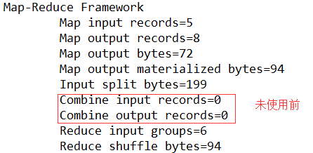
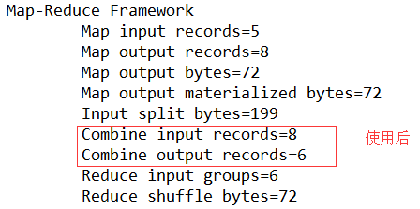

6、源代码解析，大量小文件的切片优化
将输入的大量小文件合并成一个切片统一处理，准备5个小文件。
实现过程
（1）不做任何处理，运行需求1中的wordcount程序，观察切片个数为5

（2）在WordcountDriver中增加如下代码，运行程序，并观察运行的切片个数为1
// 如果不设置InputFormat，它默认用的是TextInputFormat.class
job.setInputFormatClass(CombineTextInputFormat.class);
CombineTextInputFormat.setMaxInputSplitSize(job, 4194304);// 4m
CombineTextInputFormat.setMinInputSplitSize(job, 2097152);// 2m

7、集群上测试
（1）将程序打成jar包，然后拷贝到hadoop集群中。
（2）启动hadoop集群
（3）执行wordcount程序
[victor@node1 ~]$ hadoop jar wc.jar com.victor.wordcount.WordcountDriver /user/victor/input /user/victor/output1
尖叫提示：使用的是hdfs上的数据，当启动了hdfs服务后，使用的都是hdfs上的数据

8、本地测试
（1）在windows环境上配置HADOOP_HOME环境变量，在HDFS章节讲过
（2）在eclipse上运行程序
（3）注意：如果eclipse打印不出日志，在控制台上只显示
1.log4j:WARN No appenders could be found for logger (org.apache.hadoop.util.Shell).
2.log4j:WARN Please initialize the log4j system properly.
3.log4j:WARN See http://logging.apache.org/log4j/1.2/faq.html#noconfig for more info.

需要在项目的src目录下，新建一个文件，命名为“log4j.properties”，在文件中写入
log4j.rootLogger=INFO, stdout
log4j.appender.stdout=org.apache.log4j.ConsoleAppender
log4j.appender.stdout.layout=org.apache.log4j.PatternLayout
log4j.appender.stdout.layout.ConversionPattern=%d %p [%c] - %m%n
log4j.appender.logfile=org.apache.log4j.FileAppender
log4j.appender.logfile.File=target/spring.log
log4j.appender.logfile.layout=org.apache.log4j.PatternLayout
log4j.appender.logfile.layout.ConversionPattern=%d %p [%c] - %m%n
注意：args[0], args[1] 需要换成本地路径

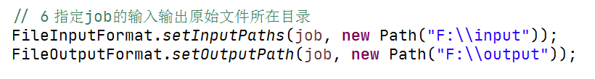

二、倒排索引案例
有大量的文本（文档、网页），需要建立搜索索引

1、数据

1）a.txt
victor pingping
victor ss
victor ss

2）b.txt
victor pingping
victor pingping
pingping ss

3）c.txt
victor ss
victor pingping

2、输出结果

1）第一次预期输出结果
victor--a.txt 3
victor--b.txt 2
victor--c.txt 2
pingping--a.txt 1
pingping--b.txt 3
pingping--c.txt 1
ss--a.txt 2
ss--b.txt 1
ss--c.txt 1

2）第二次预期输出结果
victor c.txt-->2 b.txt-->2 a.txt-->3
pingping c.txt-->1 b.txt-->3 a.txt-->1
ss c.txt-->1 b.txt-->1 a.txt-->2

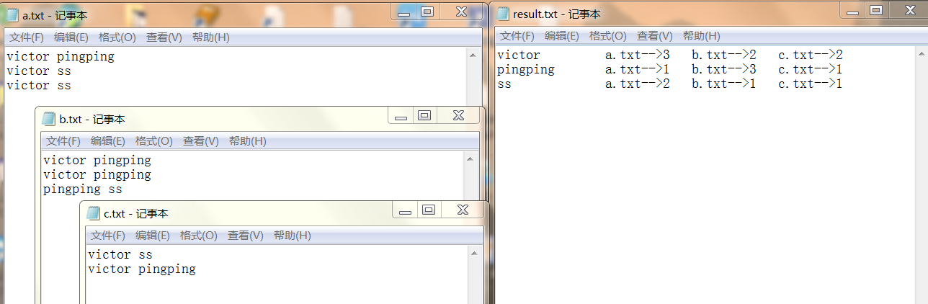

3、第一次处理

1）OneIndexMapper
import java.io.IOException;

import org.apache.hadoop.io.IntWritable;
import org.apache.hadoop.io.LongWritable;
import org.apache.hadoop.io.Text;
import org.apache.hadoop.mapreduce.Mapper;
import org.apache.hadoop.mapreduce.lib.input.FileSplit;

// k victor--a.txt
// v 个数
public class OneIndexMapper extends Mapper<LongWritable, Text, Text, IntWritable> {

String name;
Text k = new Text();
IntWritable v = new IntWritable(1);

@Override
protected void setup(Mapper<LongWritable, Text, Text, IntWritable>.Context context)
throws IOException, InterruptedException {

// 获取名字
FileSplit inputSplit = (FileSplit) context.getInputSplit();
name = inputSplit.getPath().getName();

}

@Override
protected void map(LongWritable key, Text value, Mapper<LongWritable, Text, Text, IntWritable>.Context context)
throws IOException, InterruptedException {

// 1 获取一行
// victor pingping
String line = value.toString();

// 2 切割
// victor
// pingping
String[] words = line.split(" ");

// 3 遍历输出
for (String word : words) {
// victor--a.txt
k.set(word + "--" + name);

context.write(k, v);
}
}
}

2）OneIndexReducer
import java.io.IOException;

import org.apache.hadoop.io.IntWritable;
import org.apache.hadoop.io.Text;
import org.apache.hadoop.mapreduce.Reducer;

public class OneIndexReducer extends Reducer<Text, IntWritable, Text, IntWritable> {

@Override
protected void reduce(Text key, Iterable<IntWritable> values, Context context)
throws IOException, InterruptedException {

// 累加求和
int count = 0;
for (IntWritable value : values) {
count += value.get();
}

// 写出
context.write(key, new IntWritable(count));
}
}

3）OneIndexDriver
import org.apache.hadoop.conf.Configuration;
import org.apache.hadoop.fs.Path;
import org.apache.hadoop.io.IntWritable;
import org.apache.hadoop.io.Text;
import org.apache.hadoop.mapreduce.Job;
import org.apache.hadoop.mapreduce.lib.input.FileInputFormat;
import org.apache.hadoop.mapreduce.lib.output.FileOutputFormat;

public class OneIndexDriver {

public static void main(String[] args) throws Exception {

args = new String[] { "e:/inputoneindex", "e:/output5" };

Configuration conf = new Configuration();

Job job = Job.getInstance(conf);
job.setJarByClass(OneIndexDriver.class);

job.setMapperClass(OneIndexMapper.class);
job.setReducerClass(OneIndexReducer.class);

job.setMapOutputKeyClass(Text.class);
job.setMapOutputValueClass(IntWritable.class);

job.setOutputKeyClass(Text.class);
job.setOutputValueClass(IntWritable.class);

FileInputFormat.setInputPaths(job, new Path(args[0]));
FileOutputFormat.setOutputPath(job, new Path(args[1]));

job.waitForCompletion(true);

}
}

4）第一次输出结果
victor--a.txt 3
victor--b.txt 2
victor--c.txt 2
pingping--a.txt 1
pingping--b.txt 3
pingping--c.txt 1
ss--a.txt 2
ss--b.txt 1
ss--c.txt 1

4、第二次处理

1）TwoIndexMapper
import java.io.IOException;

import org.apache.hadoop.io.LongWritable;
import org.apache.hadoop.io.Text;
import org.apache.hadoop.mapreduce.Mapper;

public class TwoIndexMapper extends Mapper<LongWritable, Text, Text, Text>{
Text k = new Text();
Text v = new Text();

@Override
protected void map(LongWritable key, Text value, Context context)
throws IOException, InterruptedException {

// victor--a.txt 3

// 1 获取一行
String line = value.toString();

// 2 切割
// victor
// a.txt 3
String[] fields = line.split("--");

// 3 处理k和value
k.set(fields[0]);
v.set(fields[1]);

// 4 输出
context.write(k, v);
}

}

2）TwoIndexReducer
import java.io.IOException;

import org.apache.hadoop.io.Text;
import org.apache.hadoop.mapreduce.Reducer;

public class TwoIndexReducer extends Reducer<Text, Text, Text, Text>{

@Override
protected void reduce(Text key, Iterable<Text> values, Context context)
throws IOException, InterruptedException {
// victor a.txt 3
// victor b.txt 2
// victor c.txt 2

StringBuffer sb = new StringBuffer();

for (Text value : values) {

sb.append(value.toString().replace("\t", "-->") + "\t");
}

context.write(key, new Text(sb.toString()));

}
}

3）TwoIndexDriver
import java.io.IOException;

import org.apache.hadoop.conf.Configuration;
import org.apache.hadoop.fs.Path;
import org.apache.hadoop.io.Text;
import org.apache.hadoop.mapreduce.Job;
import org.apache.hadoop.mapreduce.lib.input.FileInputFormat;
import org.apache.hadoop.mapreduce.lib.output.FileOutputFormat;

public class TwoIndexDriver {

public static void main(String[] args) throws Exception, IOException {
args = new String[] { "e:/inputtwoindex", "e:/output6" };

Configuration config = new Configuration();
Job job = Job.getInstance(config);
job.setJarByClass(TwoIndexDriver.class);

job.setMapperClass(TwoIndexMapper.class);
job.setReducerClass(TwoIndexReducer.class);

job.setMapOutputKeyClass(Text.class);
job.setMapOutputValueClass(Text.class);

job.setOutputKeyClass(Text.class);
job.setOutputValueClass(Text.class);

FileInputFormat.setInputPaths(job, new Path(args[0]));
FileOutputFormat.setOutputPath(job, new Path(args[1]));

System.exit(job.waitForCompletion(true) ? 0 : 1);

}
}

4）第二次输出结果
victor c.txt-->2 b.txt-->2 a.txt-->3
pingping c.txt-->1 b.txt-->3 a.txt-->1
ss c.txt-->1 b.txt-->1 a.txt-->2

三、压缩案例

1、对数据流的压缩和解压缩
CompressionCodec有两个方法可以用于轻松地压缩或解压缩数据。要想对正在被写入一个输出流的数据进行压缩，我们可以使用createOutputStream(OutputStreamout)方法创建一个CompressionOutputStream，将其以压缩格式写入底层的流。相反，要想对从输入流读取而来的数据进行解压缩，则调用createInputStream(InputStreamin)函数，从而获得一个CompressionInputStream，从而从底层的流读取未压缩的数据。
测试一下如下压缩方式：
DEFLATE | org.apache.hadoop.io.compress.DefaultCodec
gzip | org.apache.hadoop.io.compress.GzipCodec
bzip2 | org.apache.hadoop.io.compress.BZip2Codec
LZ4 | org.apache.hadoop.io.compress.Lz4Codec

1）压缩
import java.io.File;
import java.io.FileInputStream;
import java.io.FileOutputStream;
import java.io.IOException;

import org.apache.hadoop.conf.Configuration;
import org.apache.hadoop.io.IOUtils;
import org.apache.hadoop.io.compress.CompressionCodec;
import org.apache.hadoop.io.compress.CompressionOutputStream;
import org.apache.hadoop.util.ReflectionUtils;

public class TestComporess {

public static void main(String[] args) throws Exception {
compress("e:/log.txt", "org.apache.hadoop.io.compress.BZip2Codec");
// compress("e:/log.txt", "org.apache.hadoop.io.compress.GzipCodec");
// compress("e:/log.txt", "org.apache.hadoop.io.compress.Lz4Codec");
// compress("e:/test.txt", "org.apache.hadoop.io.compress.DefaultCodec");

}

// 压缩测试
private static void compress(String filename, String method) throws ClassNotFoundException, IOException {

// 1 获取输入流
FileInputStream fis = new FileInputStream(new File(filename));

// 2 获取输出流
Class classname = Class.forName(method);

CompressionCodec codec = (CompressionCodec) ReflectionUtils.newInstance(classname, new Configuration());

FileOutputStream fos = new FileOutputStream(new File(filename + codec.getDefaultExtension()));

// 3 把输出流封装成压缩流
CompressionOutputStream cos = codec.createOutputStream(fos);

// 4 对拷贝
IOUtils.copyBytes(fis, cos, 1024 * 1024 * 5, false);

// 5 关闭资源
fis.close();
cos.close();
fos.close();
}

}

2）解压缩
import java.io.File;
import java.io.FileInputStream;
import java.io.FileNotFoundException;
import java.io.FileOutputStream;
import java.io.IOException;

import org.apache.hadoop.conf.Configuration;
import org.apache.hadoop.fs.Path;
import org.apache.hadoop.io.IOUtils;
import org.apache.hadoop.io.compress.CompressionCodec;
import org.apache.hadoop.io.compress.CompressionCodecFactory;
import org.apache.hadoop.io.compress.CompressionInputStream;

public class TestDecompress {

public static void main(String[] args) throws Exception {
decompress("e:/log.txt.gz");
}

// 解压缩
private static void decompress(String filename) throws FileNotFoundException, IOException {

// 1 判断是否有解压缩的方法
CompressionCodecFactory factory = new CompressionCodecFactory(new Configuration());
CompressionCodec codec = factory.getCodec(new Path(filename));

if (null == codec) {
System.out.println("not find " + codec);
return;
}

// 2 获取输入流
CompressionInputStream cis = codec.createInputStream(new FileInputStream(filename));

// 3 获取输出流
FileOutputStream fos = new FileOutputStream(new File(filename + ".decode"));

// 4 流的对拷贝
IOUtils.copyBytes(cis, fos, 1024*1024*5, false);

// 5 关闭资源
cis.close();
fos.close();

}
}

2、在Map输出端采用压缩
即使你的MapReduce的输入输出文件都是未压缩的文件，你仍然可以对map任务的中间结果输出做压缩，因为它要写在硬盘并且通过网络传输到reduce节点，对其压缩可以提高很多性能，这些工作只要设置两个属性即可，我们来看下代码怎么设置：
给大家提供的hadoop源码支持的压缩格式有：BZip2Codec 、Lz4Codec、DefaultCodec

基于workcount案例处理，Mapper和Reducer都不用修改，只修改Driver主类
import org.apache.hadoop.conf.Configuration;
import org.apache.hadoop.fs.Path;
import org.apache.hadoop.io.IntWritable;
import org.apache.hadoop.io.Text;
import org.apache.hadoop.io.compress.BZip2Codec;
import org.apache.hadoop.io.compress.CompressionCodec;
import org.apache.hadoop.io.compress.DefaultCodec;
import org.apache.hadoop.io.compress.GzipCodec;
import org.apache.hadoop.io.compress.Lz4Codec;
import org.apache.hadoop.io.compress.SnappyCodec;
import org.apache.hadoop.mapreduce.Job;
import org.apache.hadoop.mapreduce.lib.input.FileInputFormat;
import org.apache.hadoop.mapreduce.lib.output.FileOutputFormat;

public class WordCountDriver {

public static void main(String[] args) throws Exception {

// 1 获取job对象
Configuration configuration = new Configuration();

// 开启map端输出压缩
configuration.setBoolean("mapreduce.map.output.compress", true);
// 设置map端输出压缩方式
configuration.setClass("mapreduce.map.output.compress.codec", DefaultCodec.class, CompressionCodec.class);

Job job = Job.getInstance(configuration);

// 2 加载驱动类
job.setJarByClass(WordCountDriver.class);

// 3 加载mapper和reducer类
job.setMapperClass(WordCountMapper.class);
job.setReducerClass(WordCountReduce.class);

// 4 map端输出的key 和value 类型
job.setMapOutputKeyClass(Text.class);
job.setMapOutputValueClass(IntWritable.class);

// 5 最终输出的key 和value类型
job.setOutputKeyClass(Text.class);
job.setOutputValueClass(IntWritable.class);

// 6 设置输入输出文件路径
FileInputFormat.setInputPaths(job, new Path(args[0]));
FileOutputFormat.setOutputPath(job, new Path(args[1]));

// 7 提交
// job.submit();
boolean result = job.waitForCompletion(true);
System.exit(result ? 0 : 1);
}
}

3、在Reduce输出端采用压缩
基于workcount案例处理Mapper和Reducer都不用修改，只修改Driver主类
1）修改驱动
import org.apache.hadoop.conf.Configuration;
import org.apache.hadoop.fs.Path;
import org.apache.hadoop.io.IntWritable;
import org.apache.hadoop.io.Text;
import org.apache.hadoop.io.compress.BZip2Codec;
import org.apache.hadoop.io.compress.CompressionCodec;
import org.apache.hadoop.io.compress.DefaultCodec;
import org.apache.hadoop.io.compress.GzipCodec;
import org.apache.hadoop.io.compress.Lz4Codec;
import org.apache.hadoop.io.compress.SnappyCodec;
import org.apache.hadoop.mapreduce.Job;
import org.apache.hadoop.mapreduce.lib.input.FileInputFormat;
import org.apache.hadoop.mapreduce.lib.output.FileOutputFormat;

public class WordCountDriver {

public static void main(String[] args) throws Exception {

// 1 获取job对象
Configuration configuration = new Configuration();
Job job = Job.getInstance(configuration);

// 2 加载驱动类
job.setJarByClass(WordCountDriver.class);

// 3 加载mapper和reducer类
job.setMapperClass(WordCountMapper.class);
job.setReducerClass(WordCountReduce.class);

// 4 map端输出的key 和value 类型
job.setMapOutputKeyClass(Text.class);
job.setMapOutputValueClass(IntWritable.class);

// 5 最终输出的key 和value类型
job.setOutputKeyClass(Text.class);
job.setOutputValueClass(IntWritable.class);

// 6 设置输入输出文件路径
FileInputFormat.setInputPaths(job, new Path(args[0]));
FileOutputFormat.setOutputPath(job, new Path(args[1]));

// 设置reduce端输出压缩开启
FileOutputFormat.setCompressOutput(job, true);

// 设置压缩的方式
FileOutputFormat.setOutputCompressorClass(job, BZip2Codec.class);
// FileOutputFormat.setOutputCompressorClass(job, GzipCodec.class);
// FileOutputFormat.setOutputCompressorClass(job, Lz4Codec.class);
// FileOutputFormat.setOutputCompressorClass(job, DefaultCodec.class);

// 7 提交
// job.submit();
boolean result = job.waitForCompletion(true);
System.exit(result ? 0 : 1);
}
}

